HERO STEELS LIMITED
Cold Rolling Steel Plant · Digital Transformation Initiative

MODULE M1 — DATA CAPTURE LAYER
M1-06 · Document 7 of 10
Planning Integration & Export
CSV import and SAP integration for automatic data population, the auto-source field map, and the temporary export feature
Document set — M1 Technical Blueprint
Doc | Title
M1-00 | Blueprint Overview & Index
M1-01 | System Architecture
M1-02 | Process-Wise Data Capture Design
M1-03 | UX Design & Operator Workflow
M1-04 | Data Model & Database Design
M1-05 | Role-Based Access Control & Security
M1-06 | Planning Integration & Export
M1-07 | Validation Framework
M1-08 | Audit Trail & Compliance
M1-09 | Reporting & Monitoring
Prepared for Z Company · Role: Manufacturing Digital Transformation Consultant / Industrial Software Architect
Version 1.0 · 30 May 2026 · Confidential

Contents

1. Why Integration Matters
Integration is what makes M1 fast. Every field sourced from Planning, the coil master, or the previous process is a field the operator does not type. The plan also tells each line which coils to expect, so capture is ‘pick and confirm' rather than ‘search and key'. This document defines the two inbound paths — CSV first, SAP next — the field-level auto-source contract, and the interim export feature.
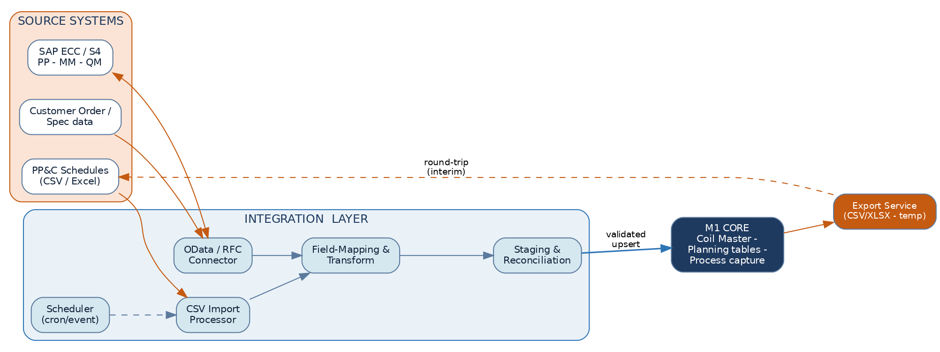
Figure. Integration layer between source systems and the M1 core
The integration layer isolates M1 from source-system detail. Connectors fetch; a mapping/transform step normalises names and units to the M1 canonical model; a staging area reconciles against existing data; and only validated records are upserted. The same staging discipline is used by both CSV and SAP, so the two paths converge before touching M1.

2. Option 1 — CSV Import (Phase 1)
CSV import delivers value on day one without waiting for SAP scope sign-off: the PP&C team's existing schedule spreadsheets are imported directly into M1's plan and coil master.

2.1 Import workflow
- Provide file — PP&C drops a CSV/XLSX to a watched folder, or Admin uploads it; a template defines the expected columns.
- Parse & map — columns map to canonical fields via a saved mapping profile; units normalised (kg→MT, etc.).
- Validate — each row checked against the import rules (below); errors collected, not fatal.
- Stage & preview — a staging batch shows valid vs error rows; Admin reviews the summary.
- Load (upsert) — valid rows create/update plan_order, coil_plan and coil master; the batch is recorded.
- Report — an import report lists loaded, updated, skipped and errored rows with reasons.

2.2 Validation & error handling
Check | On failure
Required columns present & typed | Whole file rejected with a clear header error
Coil No unique within file & not conflicting | Row flagged; existing coil offered for update not duplicate
Customer / Grade exist in master | Row errored; unknown code listed for Admin to add or map
Numeric ranges (width/thk/qty) sane | Row errored with the offending value and expected range
Dates valid & not in the past beyond tolerance | Row warned; loadable with confirmation

Partial success is supported: valid rows load, errored rows are exported back as a correction file. Re-importing the corrected file is idempotent — coils already loaded are updated, not duplicated, keyed on COIL_NO.

2.3 Scheduling
- On-demand — Admin uploads ad-hoc.
- Scheduled — a watcher polls the PP&C folder on a cron (e.g. each shift start) and auto-imports new files.
- Event — a file-arrival trigger starts the pipeline immediately.
- Every run produces an import_batch record (source, file, counts, status, who, when) for audit.

3. Option 2 — SAP Integration (Phase 2)
Once scope is agreed with plant IT/SAP, the CSV bridge is replaced by a live connection that pulls production orders, customer/grade master and QM specifications — and, in a later step, writes actuals back to SAP PP.

3.1 SAP architecture & middleware
- Connector — OData services (S/4HANA) or BAPI/RFC (ECC) exposed through SAP's integration tier (PI/PO, CPI, or an API gateway).
- Middleware — the M1 integration server orchestrates pulls, applies the mapping/transform, and manages staging, retries and idempotency.
- Auth — technical service user with least-privilege authorisations; OAuth/mTLS between middleware and SAP.
- No direct DB coupling — M1 never reads SAP tables directly; all exchange is via the service contract.

3.2 Data synchronisation flow
- Scheduled/event pull of new & changed production orders and master data (delta by change timestamp).
- Map to canonical fields & units; resolve/raise unknown customers/grades.
- Stage and reconcile against existing plan & coil master (insert/update/close).
- Upsert into M1 planning + coil master; record the sync batch.
- (Later) Write-back: on shift approval, post actuals (produced, yield, scrap, holds) to the SAP order.

3.3 Representative interfaces & mapping
SAP object | Direction | Maps to M1 | Key
Production order (PP) | Inbound | planning.plan_order | sap_order_no
Order operations / routing | Inbound | planning.coil_plan | order + seq
Customer master | Inbound | master.customer | customer_code
Material / grade master | Inbound | master.grade | grade_code
QM inspection spec | Inbound | master.grade_spec | grade + customer
Confirmations (actuals) | Outbound | from shift_log / prod_* | sap_order_no

4. Field Auto-Source Map
The contract for ‘what the operator never types'. Each field is sourced from the highest available authority; the operator only supplies measured/observed values.
Field group | Auto-sourced from | Operator supplies instead
Date / Shift / Line / Operator | System clock, device binding, login | —
Target MT, planned coil list | Planning (SAP PP / CSV) | —
Customer, Grade, Surface finish | Plan order → coil master | — (confirm only)
Nominal width / thickness | Coil master | Actual measured width/thickness
Incoming thickness / weight | Previous process output | Output thickness / weight achieved
Hardness / UTS / roughness limits | Grade/customer spec | Measured hardness / UTS / Ra
Sl. No., timestamps, totals | System (derived) | —
Defects, stoppages, crew | Codes from master (picked) | Which code, time, quantity

Net effect
With plan + coil master + previous-process carry-forward in place, roughly 55–70% of a form's fields are populated before the operator touches it — the foundation of the ≤ 30–45 s entry target in M1-03.

5. Temporary Export Feature
An explicitly interim capability so the plant keeps feeding existing spreadsheets/reports during the transition, before downstream modules and SAP write-back are live. It is documented as temporary and is retired once M5/M6 are in production.

5.1 Scope & behaviour
Aspect | Specification
Who | Supervisor (own scope), Plant Head & Admin (all) — never Operator
What | Captured entries filtered by process, date range, shift, grade, customer or coil
Formats | CSV and XLSX (canonical column names with units)
How | On-demand from a report view, or a saved scheduled export to a folder/email
Audit | Every export logged in audit.export_job (scope, params, row count, who, when)
Limits | Row-scope honours line access; large exports run async and notify on completion

Marked temporary by design
The export feature is a transition bridge, not a long-term interface. Standing data exchange with other systems is via the versioned APIs, event stream and SAP write-back — the export is removed once those are in place.

